Eisenhower–Johnson

Memorial Tunnels

Emergency Response Plan

How to Use This Plan
- Remain calm, think clearly, and act decisively. Read and understand this plan before the incident.
- Identify location and type of incident
- Open to Basic Procedures flowchart (Green)
- Follow flowchart
- Consult appropriate referenced flowcharts and procedures
- Consult procedures and guidelines for given type of incident, as well as background information and other references as needed

Plan Introduction and Scope
This plan intends to provide a comprehensive framework for the response to unpredicted incidents at the Eisenhower-Johnson Memorial Tunnels (EJMT) complex. While this plan is comprehensive for multiple types and variations of incidents, it is not possible to plan for all the possible incidents that may occur. For incidents not covered, this plan may provide useful guidance that can be adapted to the given circumstances. This plan provides both broad guidance for incident management AND specific tactical recommendations and procedures for management of specific incidents. Specific recommendations are based on the identified general principles for response, and can be modified by responders, as long as the key general principles are maintained.
This document draws on existing emergency response plans, safe operating procedures and best practices for emergency response. As knowledge and experience evolves, this plan should be modified to reflect best practices and lessons learned.

Last Revised 19 August 2018

Contents
How to Use This Plan 1
Plan Introduction and Scope 1
Facility Overview 3
Tunnel Details 3
Maps 4
Fixed Fire Suppression System 8
Ventilation System 9
Fire Response Apparatus 11
General Principles 13
Communications and Notifications 14
Basic Procedures 15
Stall – Overheat – Stopped Vehicle 17
Medical Emergency 18
Traffic Accident 20
Fire 22
Initial Procedures 24
Small Passenger Vehicle 26
Midsize Vehicle 28
Truck 30
Other 33
Hazardous Materials 34
Disengage Criteria 34
Mechanical Damage or Structural Failure 35
Hazardous Materials 36
General Guidelines 36
Specifics by Material Class 38
Flowcharts 40

Facility Overview
Colorado Department of Transportation (CDOT) Region 1 operates and maintains the EJMT, which has an elevation of 11,158 feet. The dual tunnels are approximately 1.7 miles long and carry over 10 million vehicles per year through the Continental Divide. The EJMT is one of the highest vehicular tunnels in the world; it is the longest mountain tunnel and highest point on the Interstate Highway system. CDOT plans, coordinates, and provides incident management for all traffic incidents in CDOT-owned right-of-way, including the EJMT. A traffic incident can be a vehicular accident or other event that impacts the normal flow of traffic. In addition to CDOT, the Colorado State Patrol (CSP), Summit County, and Clear Creek County are key contributors when a major incident occurs. The county boundary is within the tunnel. Traffic incidents that occur in the EJMT create safety, delay, and environmental issues due to the limited capacity provided by the two-lane-per-direction tunnel, the high traffic speeds, and high volumes associated with tourist, ski, interstate commerce, and commuter traffic. These incidents can affect Clear Creek, Summit and Eagle counties and local communities such as Vail and Georgetown.

Tunnel Details
EISENHOWER: WESTBOUND (North Tunnel)
West Portal Milepost | 213.65 | Overall Length | 8941’
East Portal Milepost | 215.35 | Average Grade | 1.6%
Structure Number | 1000/1/180 | Clearance | 13’11”
Tunnel Lining | Concrete with tile | Tunnel Width | 26’

JOHNSON: EASTBOUND (South Tunnel)
West Portal Milepost | 213.65 | Overall Length | 8960’
East Portal Milepost | 215.35 | Average Grade | 1.6%
Structure Number | 1000/1/179 | Clearance | 13’11”
Tunnel Lining | Concrete with tile | Tunnel Width | 26’

Maps
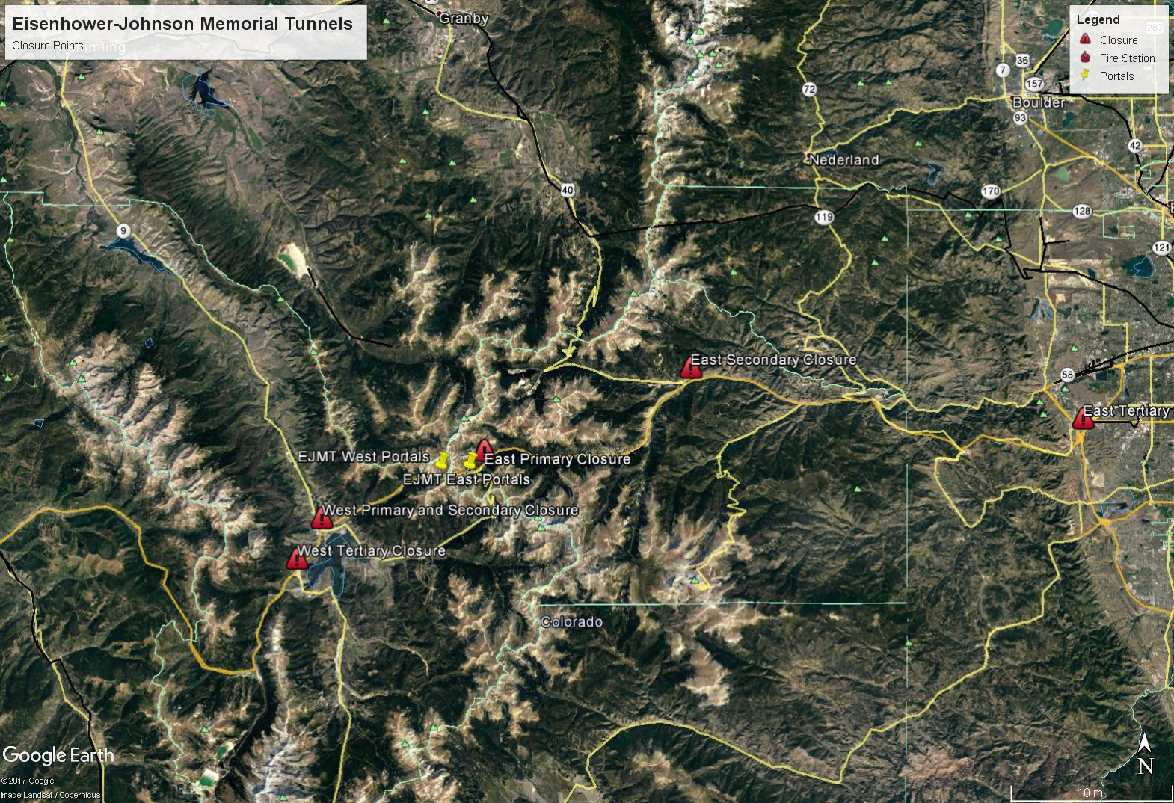
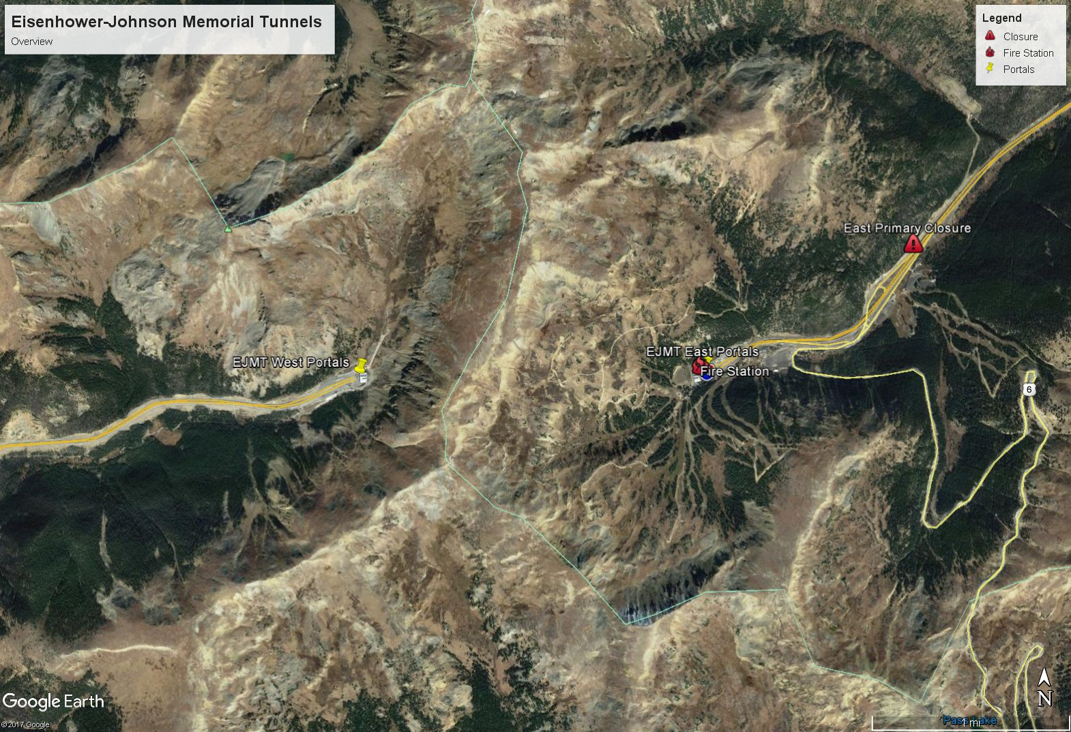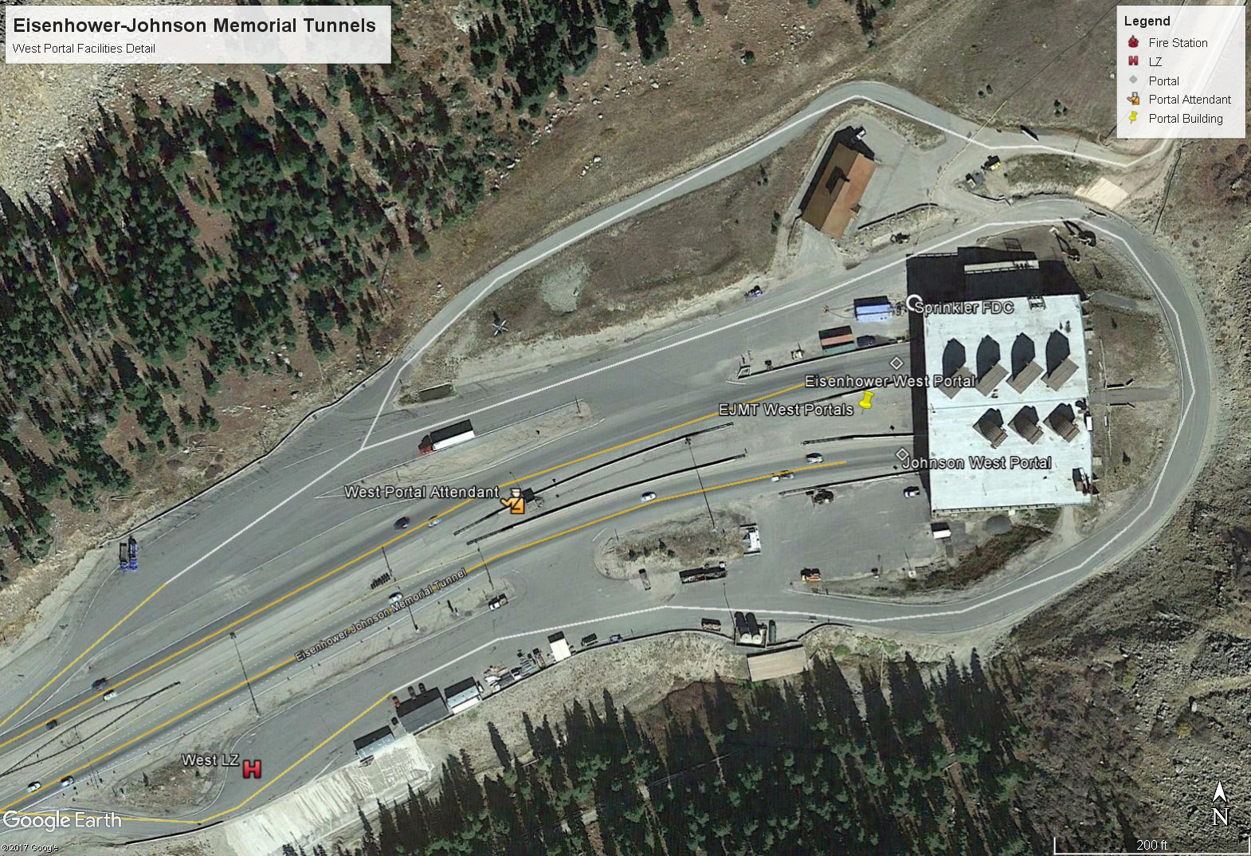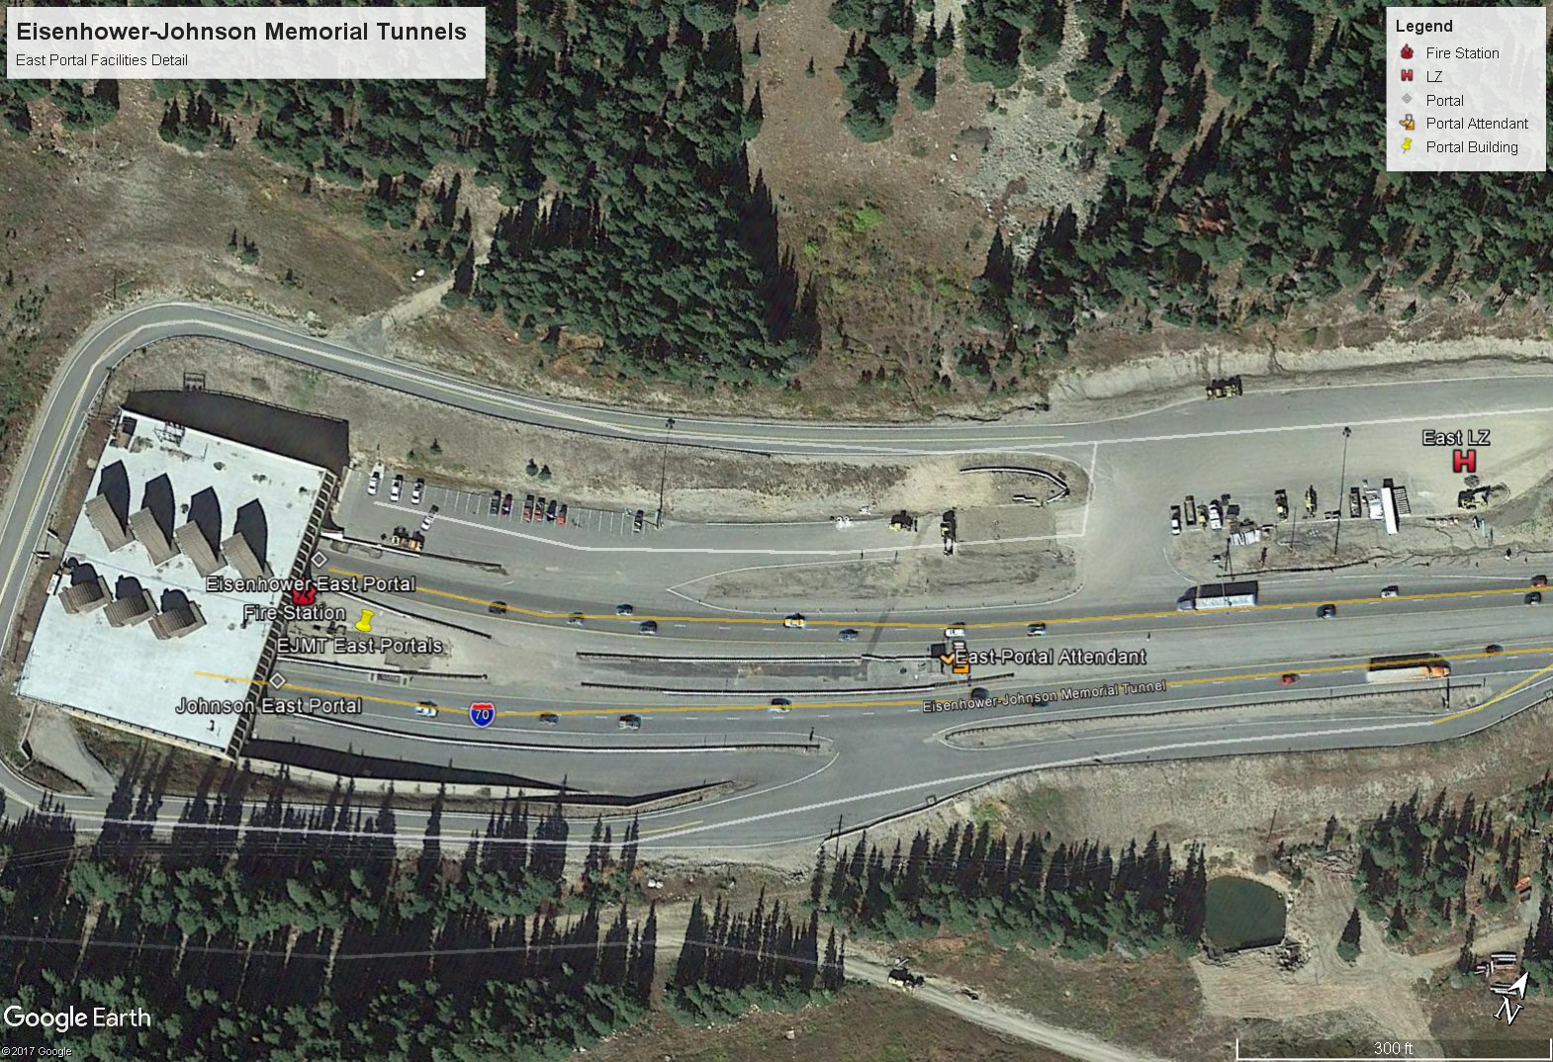

Fixed Fire Suppression System
The FFSS is designed to operate automatically. During normal operation, the Fire Alarm system continuously monitors the Fiber Optic Linear Heat Detector (FOLHD) for status and supervises other subsystems for abnormal conditions.
- FFSS Workstations: Three FFSS workstations contain one computer with two types of independent software, one for Fire Alarm control (FireWorks®) and one for the CCTV camera network (Avigilon). The workstations are redundant and located in the East Control Room (main), East Facility Manager’s office, and West Control Room. The Facility Manager’s office and the West Control Room have Fire Alarm Control Panels with soft keys that provide additional control functions. Yellow buttons are primarily for maintenance activities.
- Fire Alarm: Provides monitoring and control of the FOLHD, CCTV cameras, and major FFSS components. The FOLHD and CCTV systems are completely redundant and interconnected by a Class A (Loop) Fiber Network.
  - FOLHD: 2 fiber cables were installed inside a V-channel along the tunnel ceilings. Each zone is 100 feet long, and 3 feet of cable must be heated to activate the FFSS.
  - CCTV: 24 pan-tilt-zoom cameras total. Events are auto-recorded via redundant network video recorders.
- Water Supply: The existing water supply tank on the West side was used, which has a 120,000 gallon capacity. It will provide for one hour of system operation with two 100-foot FFSS zones operating simultaneously.
- Boiler: The boiler system maintains the FFSS supply loop at 100°F to prevent freezing when ambient air is between -30°F and 60°F. It circulates 30,000 gallons of water in 18,100 feet of 6-inch piping, and it takes 1.4 hours to fully circulate the loop. During normal operation, a single boiler and a single circulation pump will operate, switching weekly to equalize the run time. The pumps are redundant; if one fails, the other will start.
- Fire Pump: The fire pump is used to boost pressure to provide adequate flow to the systems. It is rated for 115 psi at 1250 gpm. The fire pump and boiler circulation pumps should NOT run at the same time. There is a Fire Department Connection (FDC) located on the West side. Refer to the FFSS O&M manual for more information.
- Fire Suppression: There are 183 deluge zones total in the two tunnels, and the water delivery rate is 750 gpm per zone. Each zone is 100 feet long, and water delivery is regulated by the deluge valve located in the Insulated Valve Enclosure (IVE). The IVE cabinets are installed within the plenums, and there is one cabinet per zone. There are 4 different nozzle configurations: Johnson (12), Eisenhower (3 or 4), and Portal (sidewalls).
- Electrical: The FFSS has standby and emergency power. Each major component has either battery or secondary Uninterrupted Power Supply (UPS). All other electrical equipment is backed up by generators. The existing 500kW East portal generator will power FFSS equipment on the East side. A new 350kW generator was installed to power FFSS equipment on the West. When power on the West side is switched to the existing generator during a power failure, CDOT personnel must open the 1200A breaker in the West Motor Control Center labeled “Fire Protection Fire Pump”. This will properly transfer the FFSS equipment load to the new 350kW generator. Then, once power is restored to the West side, the 1200A breaker must be closed again to its normal position.
- Automated Drainage Valves: 6 new valves were installed on the East side, as well as a new bypass line, cleanout, and New Manhole 2 for maintenance. The system will collect water from either the North OR South Tunnel, but not both. Refer to the FFSS O&M Manual for valve locations, normal positions, and alarm positions.
- Drainage/Containment Tanks: Discharge water is collected in an existing 40,000 gallon tank and two new 40,000 gallon tanks on the East side. Water is diverted to the tanks via the automated valves controlled by the Fire Alarm system. A tank level sensor was installed to indicate when tanks are full; status is reported to the FFSS workstation.
During a fire event, the Fire Suppression System operates as follows:
- When a rate of temperature change above ambient of 25°F/minute is detected by the FOLHD, a pre-alarm condition is reported at the FFSS workstation. Two CCTV cameras (one to the east, one to the west) nearest to the zone of alarm will automatically rotate to a pre-positioned setting and focus on the zone of alarm. If the zone of alarm is near the portal, only one camera will rotate.
- When a rate of temperature change above ambient of 50°F/minute OR a fixed temperature of 160°F is detected by the FOLHD, an alarm condition will be reported at the FireWorks® panel at each workstation.
- The boiler circulation pump will shut down.
- The drainage valves will change state to direct water to the drainage tanks.
- The fire pump will start.
- The deluge valve in the zone of alarm will open, and water will be delivered to the roadway.
- During the operation of the FFSS, the supply tank will report approximate water supply capacity at the following intervals: 60 minutes remaining; 30 minutes remaining and 0 minutes remaining. The 60 minutes remaining indication will be displayed immediately upon any alarm.
- The FFSS will continue to operate automatically unless manual control is taken. Manual control can be taken at any time, i.e., the person in responsible charge does not have to wait for an alarm to activate if they see a fire condition.
- A second alarm will NOT automatically activate an additional zone. The FFSS is designed to operate up to two zones at a time.
- After the FFSS is reset, the drainage valves will remain in their alarm position and continue sending water to the drainage tanks. The FFSS drainage valves must always be reset manually after each alarm.

Ventilation System
The EJMT utilizes independent, fully transverse ventilation systems for each bore with ventilation buildings at each portal. The Eisenhower Tunnel (westbound) has four supply fans (533,000 CFM) and four exhaust fans (542,000 CFM) in each ventilation building, and the Johnson Tunnel (eastbound) has three supply fans (420,000 CFM) and three exhaust fans (460,000 CFM) in each ventilation building. The exhaust and supply ducts are located side-by-side in the ceiling above the roadway, separated by a bulkhead. Transverse bulkheads at the midpoint of each tunnel separate the area of influence of each ventilation building. Fresh air can be supplied from both ends of a bore and air can be exhausted from both ends.

Fire Response Apparatus

ID 70000459/1992 Chevrolet Utility/Fire Truck.
Skid mounted pumper with 18 hp pump and motor capable of 250 gpm at 150 psi. Truck has 250 gallon water tank and 10 gallon foam tank with built in foam proportioner. Positive pressure AFFF proportioner at 6 per cent solution. Electric rewind reel with 200 feet of 1 inch hose rated for 800 psi. 2 ½ inch inlet to pump with female national standard thread, one 2 ½ inch outlet with ball valve, one outlet to 1 inch booster reel with nozzle and ball valve. 500 feet of 1 ½ inch hose in hose bed and 400 feet of 2 ½ inch hose in hose bed. 2 - 2 ½ hose clamps, 1 - 1 ½ inch x 3 ½ foot piercing nozzle, 1 – 2 ½ inch x 1 ½ inch gated wye, 2 – 1 ½ inch turbo nozzles, hydrant wrenches, and hose wrenches. 2 – 20 pound dry chemical fire extinguishers
Other Equipment: Hydraulic extrication gear, battery powered sawz-all, assorted hand tools and extrication tools, 1- Genesis 17C combination spreader/cutter (cordless), SCBA, bunker gear, and first aid equipment.

ID 700001208/2000 GMC Wrecker/Fire Truck.
50 gallon AFFF Compressed Air Foam System with 100 foot hose reel with electric rewind. 200 feet of 2 ½ inch hose, 500 feet of 1 ½ inch hose in hose bed. 2 – 20 pound dry chemical fire extinguishers.
Appliances: 1 - 2 ½ inch to 1 ½ inch gated wye, 1 – 1 ½ inch Turbo Spray nozzle, 2- 2 ½ inch Hose clamps, Hydrant wrenches, and hose wrenches.
Other Equipment: SCBA, bunker gear, assorted hand tools, hand rescue tools, and first aid equipment.

ID 70002064/1988 Pierce-Dash Fire Pumper.
750gpm maximum output with 500gpm nominal at 150 psi. Pump and go capability from within the cab utilizing the remote turret. 200 foot 1 inch booster hose on electric retracting reel with nozzle. Two pre-connected cross lays with 150 feet of 1 ½ inch hose, one connected to a 3 foot piercing nozzle and one to a Turbo Spray nozzle. A gated wye attached to the rear 2 ½ output with two 1 ½ inch by 150 foot hose lays with Turbo Spray nozzles connected. 1500 feet of 2 ½ hose in rear hose bed and 600 feet of 1 ½ inch hose in adjacent hose bed. One each, Right and Left 2 ½ inch discharge, one each Right and Left 2 ½ inch intake, one each Right and Left 5 inch draft intake. 1000 gallon water tank and 125 gallon foam tank with mixing valve.

ID 70004326/2012 Ford F-550 Flatbed/Fire Truck.
Compressed Air Foam System unit with 23 hp pump flowing 15-40 gpm at 125 psi and 15 -20 CFM air flow producing .5-1.0 per cent foam. 200 foot of 1 inch hose on an electric rewind reel. 250 gallon water tank and 15 gallon foam tank.
Appliances: 200 feet of 2 ½ inch hose, 200 feet of 1 ½ inch hose in hose beds. 2 -2 ½ inch to 1 ½ inch gated wye, 1 -1 ½ inch to 1 inch spray nozzle, 3 – 1 ½ inch turbo spray nozzles, hydrant wrenches, hose wrenches, and assorted hand tools.
Other Equipment: Rescue 42 vehicle stabilization system, hand extrication equipment, 1- Genesis 17C combination spreader/cutter (cordless), SCBA, Bunker gear, and first aid equipment.

ID 70000528/2001 IHC Rollback Truck (Wrecker)
No firefighting appliances on board

General Principles
Actions taken in response to any incident at the EJMT shall be based on the following guiding principles.
Life Safety
The preservation of life shall remain the first goal in the response to any incident. The safety of responders is the priority, followed by the safety of the affected public.
- We will risk our lives a lot, in a calculated manner, to save savable lives,
- We will risk our lives a little, in a calculated manner, to save property that is not already lost,
- We will risk nothing for lives and property that are already lost.
No property or vehicle is worth the life of a firefighter. Actions taken in a calculated manner for lives or property require:
- Establishment of incident command
- Proper personal protective equipment
- Personnel are well accounted for and trained for the tasks they are to perform
- Safety procedures are in place
- All personnel continuously assessing and mitigating risk
Each member of the responding force shall act as their own safety officer, and be the first person responsible for and ultimately accountable for their own safety.
Stabilization of the Incident
The second priority of emergency incident management is the stabilization of the incident. Broadly defined, this is the control of hazards and stopping the spread or progression of the incident. Once all threats to life have been addressed, the focus of response changes to control the incident itself. Actions to stabilize incidents can include suppression of fire (either in the defensive or offensive strategy), control of traffic, containment of leaks and other tasks to keep the incident from spreading.
Quick Clearance
Rapid clearance of highway obstructions, and easing the flow of commerce are a priority for responders on highways. Limit the duration of closures and obstructions to the minimum that is required by safety of responders and attempt to rapidly open the road once hazards are mitigated. This priority takes precedence over the protection of private property, and actions taken within reason to clear obstructions that cause damage may be justified.
Preservation of Property and the Environment
Preservation of both property and the environment must remain a goal of emergency responders. Care should be taken to limit damage done to personal and public property and to preserve the environment as possible, so long as other priorities are met first. Limit spilled materials, attempt to control loss from fire quickly and move vehicles with minimal damage.

Communications and Notifications
Communications are vital to get the message to the receiver correctly, and then acknowledgement back to the sender. By doing this, if the receiver sends back the same message, the sender can say: “Affirmative, or, Negative” (if not correct).
- Control Room Operator (CRO) to the emergency responders—must give a description of what the emergency is and what they are responding to.
- Location—where is the emergency, what is the segment/section, what is the emergency, where is the closest fire hydrant if needed, etc.
Notifications must be done quickly and accurately.
- CRO—1) hold traffic; 2) start fans (immediately if a fire is part of the emergency); 3) Notify your supervisors through chain-of-command.
- Relay information to the EJMT responders.
- Immediately notify Summit FES, and, Clear Creek Fire Departments.
Important Radio Communications to Remember:
10-10-10—Inside Tunnel emergency (Fire).
10-33—Outside Tunnel Emergency.

Basic Procedures

*Contact Supervisor.
When an incident is identified or reported to the EJMT Control Room Operator, the steps taken immediately after that report define the tone and ultimately the outcome of an incident response.
Receive report of incident
Incident notification may occur via telephone, radio, the integrated alarm system for the FFSS or by direct observation of the CRO or other staff. Remain vigilant to notification methods and maintain open channels as best as possible to prevent delays on message transmission.
Identification of an Incident
Once it is identified or reported that an incident is taking place, normal operations must take a subordinate role to response to the emergency. Any personnel not involved in incident response should stop work and report to their assignment for emergency response or report to a staging area and await assignment.
Stop Traffic
The flow of traffic into the tunnel while an incident takes place endangers the lives of the victims and responders, and presents a real threat to complicate the incident with secondary collisions. Upon discovery of an incident, traffic should be stopped immediately in the affected bore. In the event of a fire incident, all traffic should be stopped and diverted.
Visualize with Cameras or Personnel
Some sort of observation of the incident is needed, either by the person who identified and reported it or via CCTV cameras at the control room. Use this information as observed to begin collecting information and formulating a plan for response and resource needs.
Type of Incident
Attempt to characterize the incident based on what can be safely observed. Some circumstances may be obvious (trip of heat detector and smoke observed indicates fire), while others may present multiple options for responders. Based on observations and other reported information, characterize the incident as:
In the absence of clear information, treat the incident as a crash or fire until proven otherwise.
- Fire
  - 10-10-10 (fire inside tunnel)
  - 10-33 (fire outside tunnel)
- Crash
  - 10-50
- Mechanical Damage / Structural Failure
- Stalled / Stopped / Overheated Vehicle
- Medical Emergency
Go to that Type
Based on this characterization, go to the appropriate page of flowchart and section for that type of incident. Each incident type is color-coded in this manual for ease of reference.

Stall – Overheat – Stopped Vehicle

While disabled vehicles, stalls or overheating incidents are the most common reason for an incident at the EJMT, efforts should be taken to ensure that responses are emergent traffic. Many notable and fatal tunnel fires worldwide started as this type of incident.
Identify Location and Complexity
Attempt to locate and identify the stranded vehicle as soon as possible, as this can dictate what resources are required. If it is an apparently simple passenger vehicle stall as opposed to a truck, this can change personnel required and complexity of the operation.
Respond with Wrecker and Crew of 1+
Staff the wrecker and respond with a crew of one or more trained responders. Make sure all responders have appropriate PPE for towing and salvage work BEFORE leaving the center section. Respond with the flow of traffic to reach the scene, do not rely on lights and sirens for counter flow or abrupt movements.
Communicate with Driver on Arrival
When arriving on scene, examine scene and make contact with the driver. Use either the PA speaker on the wrecker or make face-to-face contact to explain what is happening and the fact that you are going to move their vehicle. Do not permit them to exit their vehicle onto the roadway, make it clear that their vehicle will be moved from obstructing traffic. Be polite, professional and brief.
Determine Method for Removal
When making contact and approaching vehicle, begin to determine what process will be needed to extract the vehicle. A simple push using the push bumper is a viable option for smaller vehicles that can roll safely, and is a quick and effective means for clearance. If the vehicle is too large to be pushed, consider towing methods of removal. Remain vigilant for traffic encroachment or fire.
Remove Vehicle
Safely extract vehicle from tunnel using chosen method. Drop stranded vehicle at the parking lot at the portal and explain their need to contact tow or have CSP arrange for a tow for their vehicle from there. Examine the vehicle at the conclusion of the tow to note any damage, and document this after the incident.
Reopen to Traffic
Once towing or removal begins, traffic flow can begin to be restored. Open first the unaffected lane using LUS signals and open all lanes once vehicles are cleared.

Medical Emergency

*Contact Supervisor.
Medical emergencies, while unlikely, may occur for both the public and CDOT personnel. Follow CDOT accident and mishap procedures for injuries to personnel, in conjunction with this protocol.
Request Local EMS Assistance
Local Emergency Medical Services (EMS) from Summit County Ambulance or Clear Creek EMS will be required for care and transport of sick or injured persons. Provide specific and clear information on what is needed and the nature of injury if known.
Consider LZ Setup for Flights
In coordination with local EMS, consider aeromedical evacuation for a critically injured or ill patient. Several locations for landing zones exist at the EJMT complex and can be set up if unoccupied. A minimum of 100’ by 100’ is required. Area must be free of any obstructions, look for wires in the air. Location must be well lit, but be sure do not point the lights towards the sky as it may blind the helicopter pilots from seeing the area. All responders must wear safety glasses due to helicopter turbulence on landing and take-off. (The down draft from the helicopter propellers may be 100 mph or more.)
Locate Ill or Injured Patient
Locate them and a good way to access/extract them. Some locations at the complex may present a challenge to access and extract victims, so spend time planning before EMS arrival.
Respond
Respond to the scene using the CAFS or mini-pumper or other appropriate truck carrying medical equipment. Respond safely, with the flow of traffic to reach the scene, do not rely on lights and sirens for counter flow or abrupt movements.
Stabilize Victim
Take appropriate actions as trained, certified and permitted. Attempt to stabilize the patient as best as possible before the arrival of local EMS. If the patient’s oxygen is below 90 (use the pulse oximeter), then, it is permissible to give oxygen. If EJMT employee(s) give oxygen, 911 ambulance MUST be called. When applying oxygen, apply at 8 liters. Ask the patient if they have emphysema or COPD (chronic obstructive pulmonary disease), if they do keep it at 8 liters unless medical people direct you to go higher on giving the oxygen. If there is no lung or breaking diseases, you may give up to 115 liters of oxygen. Remember, if you give oxygen, they must be seen by an ambulance crew. Be sure to do the required paperwork.
Coordinate Transportation with EMS
Work with local EMS responders to determine the best method to transport the patient to definitive care. This may involve the use of CDOT vehicles in unconventional ways, and these choices should be made with considerable concern for safety of responders and the victim.
Reopen Tunnel or Affected Area
Once patient is transported, limit delay time as best as possible by opening the roadway or affected area quickly. Complete documentation as required.

Traffic Accident

*Contact Supervisor.
In the event of any traffic accident or crash within the tunnel, some general procedures will guide the choices needed to mitigate the incident.
Request Assistance
For a traffic accident, notify and request assistance from local fire, EMS and CSP. Consider a ground standby request from Flight for Life for serious crashes.
Respond with Engine/CAFS/Mini-pumper and Wrecker
This response both provides equipment to manage the incident and to clear the scene. Also adequate personnel to stabilize and manage the incident are provided. Make sure all responders have fire PPE and appropriate PPE for towing and salvage work BEFORE leaving the center section. Respond with the flow of traffic to reach the scene, do not rely on lights and sirens for counter flow or abrupt movements.
Size Up the Scene
When arriving on scene, provide a clear and concise description of the incident, including:
- Location of the incident (segment and lane)
- Vehicles involved and damage
- Persons trapped or injured?
- Lanes obstructed
- Actions to be taken and requests for resources
Lanes Obstructed?
If both lanes are obstructed or will be obstructed by response actions, keep both lanes closed. If one lane can be opened safely, open it, using LUS signals and apparatus placement to safely guide traffic around the scene. Follow established procedures for lane closure if incident extends beyond 30 minutes.
Persons Trapped?
If persons are trapped or suspected to be trapped, take the following actions:
- Keep both lanes closed (regardless of obstruction)
- Order additional resources for extrication or rescue
- Work with assisting resources to extricate victims from the crashed vehicles
- Treat injured per next section
Persons Injured?
- Stabilize Victim
  - Take appropriate actions as trained, certified and permitted. Attempt to stabilize the patient as best as possible before the arrival of local EMS.

- Coordinate Transportation with EMS
  - Work with local EMS responders to determine the best method to transport the patient to definitive care. This may involve the use of CDOT vehicles in unconventional ways, and these choices should be made with considerable concern for safety of responders and the victim.
If Hazardous Materials Involved
If any hazardous materials are involved or suspected to be involved, reference hazmat sheet and reference section.
If Damage to Facility
Go to the Mechanical Damage/Structural Failure sheet and reference section.
Clear Wreckage from Tunnel
Once accident investigation is completed by CSP, particularly if there are injuries or fatalities, wreckage should be cleared from tunnel. Work with towing company or use CDOT resources to clear the wrecked vehicles from the affected tunnel.
Inspect Crash Scene
Examine the crash scene for damage to the tunnel facility. If any damage is noted, maintain closure of the tunnel and go to the sheet and reference section for tunnel damage. If no damage is apparent, the tunnel may be opened. (Refer to page 28)
Reopen Tunnel to Traffic
Once the wreckage is cleared AND the tunnel is inspected and found undamaged, it is OK to reopen the tunnel to the normal flow of traffic. Complete documentation as required, and return all equipment to a condition ready again for response.

Fire

*Contact Supervisor.
Fire incidents present a considerable risk to both responders and the public, and aggressive mitigation and response actions by EJMT responders may make the critical difference in the outcome of the incident, but an effective and judicious risk management decision must be made on the safety of a given method. The safety of responders must remain the first priority in incident decision-making. This plan references three key terms for strategic choices; offensive, defensive, and nonintervention. The selection of a fire suppression strategy or incident management strategy must be made by the incident commander and announced to all involved in response (generally verbally to crew and via radio to dispatch or CRO).
Offensive Strategy
Offensive strategy, or offensive mode is taking direct action against a fire, such as directly approaching a burning vehicle with a hose line, applying water and forcing entry into the vehicle to rapidly affect extinguishment. Offensive strategy is a high-risk method of action, and should only be undertaken when there is considerable benefits present. Offensive tactics are justified where actions can result in a rapid suppression of a fire or victims are potentially present in the fire area and require rescue. (*Note: as Engine 2064 approaches, the Driver/Operator may make the decision to use the deck gun (turret) or piercing nozzle to do a quick knockdown of the fire. Then, he/she may decide to use a hose-line for an attack line. This is dependent on many factors that are taking place at that time, including but not limited to the amount of fire and risk to occupants of the vehicle emergency.)
Defensive Strategy
A defensive strategy or mode is taking action against the fire where personnel are still taking action against the fire, but with minimal risk and generally from the distance. Defensive actions include the use of the Fixed Fire Suppression System, distant application of water using the deck gun or ground monitors, or other actions still suppressing the fire with minimal risk. Defensive strategy is selected when the risk presented with an offensive attack does not have reasonable chance of reward, or actions taken in offensive mode fail to produce the desired results in a timely manner. For example, a truck fully involved with fire with no persons at risk is a defensive situation – the risk to personnel is not justified.
The incident commander is responsible for observing progress toward incident objectives and determining if the current strategy is effective or if a change in tactics or strategy is required. When conditions are marginal (decision between offensive and defensive is not clear cut), offensive actions are justified only for rescue. Once search and rescue is completed, personnel should withdraw to a safe distance and initiate defensive operations.
When transitioning to a defensive strategy from an offensive strategy, command must announce this strategic change over the radio and ensure accountability of all personnel potentially in the hazard area.
(*Note: The CRO (Control Room Operator) will ask for and give a PAR report (Personnel Accountability Report). This is required so that all personnel responding on the emergency (alarm) is accounted for and safe. After this is done, the IC/CRO reports to the Control Room Operator (CRO) that the emergency scene is PAR. The CRO repeats it, and states “Affirmative, the emergency scene is PAR.
*Note: for a long duration emergency, this should be done approximately every 20 minutes. If there is a single resource person that is the Safety Officer, he/she may be the individual that initiates this PAR report. Documentation that it occurred is mandatory.
Nonintervention Strategy
A nonintervention strategy may be selected by command when risk of any action against the incident is not justified. This is appropriate for large fires, hazardous materials spills or other incidents that pose considerable risk even when personnel are somewhat distant but still in the tunnel.

Initial Procedures

*Contact Supervisor.
Fire can be identified by either the FFSS fire alarm, visual identification or verbal report. For confirmed smoke or fire, as identified by visual or FOLHD, the following sequence of incident management steps must be taken. When attempting to identify if the observed condition is smoke or fire, look for the following:
- Dark black, grey, brown or similar colored smoke from the engine compartment
- Flames
- Smoke or steam of any color from the passenger compartment
Disengage Criteria
During response actions, be alert for disengagement criteria and carefully consider strategy choices on arrival. The full list of disengage criteria are later in this section.
Evacuation Alarm and Make Notifications
Upon identification of any fire or actual smoke condition inside the tunnel, trigger the evacuation alarm for the entire tunnel. This alarm should cause the public to initiate self-rescue actions and attempt to evacuate the tunnel on their own. Notifications for a possible extended closure will be required for any fire incident, particularly larger fires. Staff Bridge inspection unit should be notified as well to provide inspection and assistance from a technical perspective.
PPE For FIRE RESPONSE
- Fire helmet
- Nomex flash hood
- Bunker coat
- SCBA and facepiece, connected to breathing air
- Bunker pants
- Boots
- Flashlight
- Portable radio
- Gloves
Identify Type and Size of Fire
Determine if the fire incident is:
- Smoke only
- Passenger car
  - Sedan, SUV, hatchback, pickup truck
  - Any vehicle smaller than a large pickup truck without cargo
- Midsize vehicle
  - Large pickup truck with cargo
  - RV or trailer
  - Multi-passenger van
  - Delivery box truck
- Truck
  - Semi-tractor trailer
  - Large box truck
  - Large RV
  - Bus
- Facility or outside
  - Within the facility itself (not the tunnel bore)
  - Wildfire / grass fire
  - Vehicle fire outside the tunnel bore
Also attempt to determine if hazardous materials are present or potentially involved as soon as possible.
Smoke Only
- Ramp up ventilation to the affected area
- Respond with an engine with crew of 1-2+ and with a wrecker
- Investigate the suspect/smoking vehicle
  - Approach vehicle with full PPE for fire suppression (including on-air)
  - Consider approaching with a dry chemical extinguisher in-hand
  - Approach carefully, observing where the smoke rises from and what may be the cause
  - Investigate the cause of the smoke, looking for smoldering or flaming combustion
- Determine if the vehicle is on fire
  - If the vehicle is on fire, attempt rapid knockdown with extinguisher or CAFS system, or switch to vehicle type on separate flow sheet
- If not on fire (no flames), remove vehicle from tunnel quickly and safely
  - Move vehicle using wrecker and remain behind with engine.
  - Observe for growing plume of smoke or flames
  - If the vehicle catches fire, disengage tow, back off and initiate fire attack for that vehicle type.

Small Passenger Vehicle

*Contact Supervisor.
These procedures apply for small vehicles, generally no larger than a pickup with cargo.
Engage FFSS
Upon identification of a working vehicle fire, if the FFSS has not already tripped from heat detection, the CRO should manually engage the suppression system for the affected zone. Even if the presence of flames is uncertain, deployment of the FFSS may help prevent the fire from growing if present.
Ramp up Ventilation
The CRO should ramp up ventilation for the affected tunnel as soon as possible – effective ventilation clears the smoke/steam mix created by the FFSS and allows for both victims to escape and for the fire to be safely attacked. Follow identified ventilation procedures for that specific fire zone for which fans should be set to what setting.
Respond with Engine
The minimum response to a vehicle fire incident shall be Engine (pumper) 3804 with a crew of two or more. Response should proceed into the affected tunnel via the safest way possible, potentially including counter flow movement in the opposing bore. The engine driver/operator should make this determination in coordination with the CRO based on traffic conditions, location of the fire, and location of escaping victims.
Size up Scene
Upon arrival to the scene, provide a detailed size up to the control room operator, including:
- Location of the fire within the tunnel
- Type of vehicle
- Amount of involvement (engine, passenger compartment, trunk, full vehicle)
- Victims (presence and number)
- Strategy
- Attack plan
If Rescues Required
If rescues of victims are required, take immediate action to affect rescue. This can include rapid approach without a hose line, quick actions with a hose to knock fire near victims and such. If victims are noted, a second truck should proceed into the tunnel to help transport the victim to the tunnel portals for evaluation and care by EMS.
Locate the Fire
Locate the fire on the affected vehicle. Based on the location, tactical choices on actions may be different.
- Engine compartment only
  - Use a piercing nozzle attached to 1-1/2” attack line driven into engine compartment
  - Flood engine compartment with AFFF/Class A foam
  - Attempt hood release latch from vehicle interior
  - Use Halligan to open secondary catch or to pry up a corner of the hood
  - Disconnect battery cable once fire is extinguished
- Passenger compartment or exterior only
  - Approach vehicle from 45 degree angle
  - Apply AFFF or water to burning area of vehicle with 1-1/2” line
  - Open affected compartment to ensure good coverage of extinguishing agent
- Fully involved
  - Attempt to knock fire down with water stream from 1-1/2” attack line
  - Approach slowly, widen nozzle pattern as needed
  - Attempt to cover all areas of the fire with stream and achieve a ‘knock’ on the fire
Overhaul
Once the main body of the fire is extinguished and flames are largely gone, the suppression phase ends and switches to the overhaul phase. Using forcible entry tools, saws and other equipment, open up and expose affected areas. Smother these areas with either a water or foam blanket after identifying their potential involvement in the fire. The primary goal of overhaul efforts is to ensure the entire fire is extinguished, not just the main body of the fire.
Remain on-scene once overhaul is completed, and monitor atmosphere for clear air at the fire site. Keep the tunnel closed until inspected by an engineer and cleared for release.

Midsize Vehicle
*Contact supervisor.
Midsize vehicle fires are defined as those larger than a pickup truck with cargo and those smaller than a full semi-tractor trailer. This can include recreational vehicles, trailers, heavily loaded pickups, delivery trucks and such. These fires present the greatest risk for responders as they may appear in a grey area between offensive and defensive. For these fires, a transitional strategy of knock from a distance then approach is recommended.
Engage FFSS (Fixed Fire Suppression System)
Upon identification of a working vehicle fire, if the FFSS has not already tripped from heat detection, the CRO should manually engage the suppression system for the affected zone. Even if the presence of flames is uncertain, deployment of the FFSS may help prevent the fire from growing if present.
Ramp up Ventilation
The CRO should ramp up ventilation for the affected tunnel as soon as possible – effective ventilation clears the smoke/steam mix created by the FFSS and allows for both victims to escape and for the fire to be safely attacked. Follow identified ventilation procedures for that specific fire zone for which fans should be set to what setting. These fires require aggressive ventilation, the clearing of smoke and steam makes attack possible.
Determine if Lives are at Risk
The CRO should attempt to determine if lives are at risk in the area affected by the fire. If lives are not at risk, a less aggressive/more defensive approach is recommended for attack and mitigation. If lives are potentially at risk (persons in the fire area), actions taken must focus on the saving of lives first and foremost.
If Lives are at Risk
- Respond with Engine (crew of 1+) and CAFS/mini-pumper (crew of 1+)
- Team: Search and rescue
  - Search the affected area for victims. Use sight, sound and touch to attempt to search all survivable spaces for persons that may be trapped.
  - If victims are located, use CAFS/mini-pumper to evacuate them to the portal
  - If no victims found, assist suppression team
- Team: Fire Suppression
  - One member establishes a connection to a hydrant/standpipe, then sets up a 2-1/2” attack line for a deluge operation ao attempt knockdown
  - Other member is to operate the pump panel and consider setting up to use the deluge gun off the truck. The deluge gun should only be used once the connection to hydrant/standpipe is set up and flowing water
  - When personnel become available and the fire darkens down, use a second 1-1/2” attack line to advance on the fire and attempt suppression

If Lives are NOT at Risk
- Respond with an engine crewed with 1-2 (and prepare other apparatus to assist if needed)
- Respond to near the scene, maintaining a minimum of 100+ ft distance from the fire
- Divide crew, and accomplish the following simultaneously:
  - Set up water supply (connect engine to hydrant), then pull a second attack line (1-1/2”)
  - Operate the pump, potentially engaging deluge gun once hydrant flow is established
- Apply water in short bursts to fire, observing if fire darkens with application of water and FFSS discharge
As Fire Darkens
Make slow approach to the fire scene, observant of both the condition of the tunnel and the affect hose streams have had on the fire. Look for loose material, apparent damage or hazardous materials. Approach carefully from a 45-degree angle, observant for tires exploding or other parts failing catastrophically.
Disengage FFSS (fixed fire suppression system)
When approaching the fire scene once it has darkened down, shut down the FFSS. This improves visibility for overhaul, makes overhaul actions safer and easier, and conserves water that may be needed for overhaul.
Complete Extinguishment
Apply a water or foam stream to the remaining apparent fire once up next to the vehicle. Cover all burning areas, suppressing fire and cooling fuels.
Overhaul
Once the main body of the fire is extinguished and flames are largely gone, suppression switches to overhaul. Using forcible entry tools, saws and other equipment, open up and expose affected areas. Smother these areas with either a water or foam blanket after identifying their potential involvement in the fire. The primary goal of overhaul efforts is to ensure the entire fire is extinguished, not just the main body of the fire.
Remain on-scene once overhaul is completed, and monitor atmosphere for clear air at the fire site. Keep the tunnel closed until inspected by an engineer and cleared for release.

Truck
*Contact supervisor.
Truck fires represent a worst-case scenario and present considerable risk to personnel and the facility itself. Caution is encouraged with any response to a suspected truck fire, and additional resources will be required to even consider an attack on these fires.
Order Additional Resources
Additional resources from surrounding fire jurisdictions will be needed for a successful attack on a truck fire. Consider ordering the following:
- Type 1, 2 or 3 Engines, 2-3x
- ALS Ambulance(s), 1-2x
- Water tenders, 2-3x
Engage FFSS
Upon identification of a working vehicle fire, if the FFSS has not already tripped from heat detection, the CRO should manually engage the suppression system for the affected zone. Even if the presence of flames is uncertain, deployment of the FFSS may help prevent the fire from growing if present.
Ramp up Ventilation
The CRO should ramp up ventilation for the affected tunnel as soon as possible – effective ventilation clears the smoke/steam mix created by the FFSS and allows for both victims to escape and for the fire to be safely attacked. Follow identified ventilation procedures for that specific fire zone for which fans should be set to what setting. These fires require aggressive ventilation, the clearing of smoke and steam makes attack possible.
Pressurize the unaffected bore, by using a high intake setting with no exhaust. This will render that tunnel a safe haven for responders and a staging area for parts of the response.
Are Responders Available?
A minimum of six responders will be required for a safe attack on a truck fire, even using defensive strategy. If fewer than six responders are present, DO NOT ENGAGE. Wait for mutual aid resources to arrive and assist. Once six or more responders are on scene, it may be safe to begin an attempt to control the fire.
Engine with 1+
- Respond into affected tunnel, as close as is possible or safe
  - Consider counter flow movement and approaching from downstream
  - Remain alert for victims attempting to escape
  - Stay 150-250 feet away from the fire scene
- Divide crew, and accomplish the following simultaneously:
  - Set up water supply (connect engine to hydrant), then pull a second attack line (1-1/2”)
  - Pull and set up 2-1/2” attack line as a ground monitor
  - Operate the pump, consider engaging deluge gun once hydrant flow is established
- Be alert for victims or hazardous materials, assessing progress and achieving incident objectives.
Second Truck (Mutual Aid Engine, CAFS/Mini-Pumper) with 1-2+
This apparatus will be assigned to establish a Rapid Intervention Team (RIT) for the safety of the attacking engine. Personnel need full PPE and should be prepared to take rapid action for firefighter rescue in the event of an emergency
- Respond into the unaffected tunnel to the closest cross passage to the fire, on the same side of the fire as the engine. (As close as possible to engine)
- Proceed into the cross passage, leaving door open on the unaffected side and stage near door on affected side. Personnel should remain staged in this location and be ready if needed to rescue downed firefighters.
If an Additional Engine Becomes Available
This additional responding engine can be a resource to provide an additional hose stream from the opposite side of the fire.
- Respond into the unaffected bore, to the closest cross-passage on the opposite side of the fire attack engine.
- Connect into hydrant
- Set up a 2-1/2” line to the cross-passage standpipe and in position as a ground monitor in the affected tunnel
Monitor Progress
Observe the effects of the fire attack on the fire. Is the fire size decreasing or still growing? Also observe the surrounding areas for hazards or damage to tunnel infrastructure. If progress is not adequate, or facility becomes damaged, consider withdrawal to a nonintervention mode.
As Fire Darkens
Make slow approach to the fire scene, observant of both the condition of the tunnel and the affect hose streams have had on the fire. Look for loose material, apparent damage or hazardous materials. Approach carefully from a 45-degree angle, observant for tires exploding or other parts failing catastrophically.
Disengage FFSS
When approaching the fire scene once it has darkened down, shut down the FFSS. This improves visibility for overhaul, makes overhaul actions safer and easier, and conserves water that may be needed for overhaul.
Overhaul
Once the main body of the fire is extinguished and flames are largely gone, suppression switches to overhaul. Using forcible entry tools, saws and other equipment, open up and expose affected areas. Smother these areas with either a water or foam blanket after identifying their potential involvement in the fire. The primary goal of overhaul efforts is to ensure the entire fire is extinguished, not just the main body of the fire.
Remain on-scene once overhaul is completed, and monitor atmosphere for clear air at the fire site. Keep the tunnel closed until inspected by an engineer and cleared for release.

Other
*Contact supervisor.
Other fires include any fire not inside a bore of the tunnel, such as wildfires, structure fires or vehicles outside the tunnel.
Locate the Fire
Locate where the fire is located or is threatening. Use cameras, personnel or the initial report of the incident to assist in determining this.
Wildfire
For a wildfire (grass, trees, other) along the side of the road as visible from EJMT or EJMT’s cameras, follow these steps:
- Notify appropriate local fire districts immediately (Summit Fire & EMS, and, Clear Creek Fire Department). (There should be a speed dial number already.) Have them stage ½ mile away and outside of the tunnel.)
- Notify the U.S. Forest Service immediately. (there is an office located in Silverthorne)
- If the fire is within 100 ft. of the road, respond with engine or mini-pumper/CAFS truck to attempt quick control
- If fire is further away, monitor growth and be prepared to assist local fire in incident management. Tasks may include traffic control, water supply or similar uses of apparatus.
- If fire is moving towards ammunition depots at Loveland Ski area, stay away a minimum of ½ mile. Depending on the ammunitions, it may have to increase to 1 mile.
- Confer with the CRO supervisor or higher echelon positions, whether to shut down the traffic through both bores.
Structure Fire
A structure fire at the EJMT facility presents significant risk to both tunnel operations and EJMT responders. For a confirmed fire in the facility:
- Notify local fire district (Lake Dillon or Clear Creek)
- Shut down tunnel operations
- Evacuate affected building
- Consider assisting local fire in response. EJMT firefighters are not generally trained and qualified for structure fire interior attack, and can assist with outside tasks as approved by supervisors.
Vehicle Outside of Tunnel
- Consider notification of local fire department, particularly if vehicle is midsize or larger.
- Respond with engine or CAFS or mini-pumper and attempt to extinguish fire

Hazardous Materials
*Contact Supervisor.
Involvement of hazardous materials generally precludes any offensive or defensive strategy of mitigation. Consult the ERG, and generally do not enter the tunnel unless guide pages state this material has no influence on fire control.
Refer to the hazmat sheet and hazmat reference section for additional information.

Disengage Criteria

WHEN TO DISENGAGE FIXED FIRE SUPPRESSION SYSTEM
- Fire darkened down either by FFSS alone or combined firefighting efforts AND personnel on scene ready for approach.
- Poor visibility created by FFSS so that fire attack is not possible, and personnel on scene ready for approach and direct attack.
- Hazardous materials involved that are water reactive
- *This must be coordinated between the senior emergency responder and CRO.

WHEN TO DISENGAGE FIRE ATTACK
(Switching to a defensive or nonintervention mode)
- Structural failure (actual or impending)
- Out of water
- Ventilation failure
- Fire not darkening down with sustained fire attack efforts
- High heat preventing attack
- Insufficient personnel able to continue attack
- Hazardous materials involved that compromise efforts
- Firefighter missing, down, out of air or other MAYDAY criteria
- Change in tactics determined for other reason by IC or experts
- When you are Unsure of what to do.

Mechanical Damage or Structural Failure
Mechanical damage to the tunnel facility is a routine occurrence, notably from overheight vehicles and routine wear and tear on the facility. Structural compromise or failure is less common, and requires attention from specialists and engineers.
Persons Trapped?
If persons are trapped or injured, treat the incident as a crash until the threat to life is mitigated. Go to the crash flowchart sheet and reference pages.
Assess Damage
Respond to the scene and safely control hazards from traffic. Assess the damaged area and the surroundings first from a distance then up close.
Less than 6 inch Diameter Material Fallen or Scrape
If the largest material fallen is no bigger than 6” diameter, or is a facility sign, LUS or VMS signal, requirements are less strict than larger material fallen.
- Assess damaged area, noting depth and width of damage on the walls or roof.
- Document the damage, both in writing and with photos
- Notify Staff Bridge and R1 engineering of the damage, providing documentation of the incident and damage
- Clear debris from roadway
- Open to traffic
Large Material
If material fallen is larger than 6 inches in diameter, or concern of deeper or widespread damage is present, assess and document damage from a safe distance. Request an emergency inspection from Staff Bridge or from R1 engineering, and maintain closure until cleared by the engineering staff.

Hazardous Materials
Hazardous materials, while intentionally limited from potential risk, may still be within the EJMT facility and incidents may occur involving them. These incidents present considerable risk to responders and the public, and once any life safety risks are mitigated, the response should slow in tempo, where actions need to be more calculated and slow. These guidelines should be used in conjunction with expert advice and subject matter experts, as well as published resources such as the Emergency Response Guidebook (ERG), WISER and CAMEO. IF YOU DO NOT KNOW, DO NOT GO, FOR IT MIGHT BLOW!

General Guidelines
*Contact supervisor.
Notify CSP Hazmat and Local Fire
Immediately contact Colorado State Patrol for Hazmat Team response and local fire jurisdictions for any suspected or confirmed hazmat incident. Their resources will be essential for the operations in response to this incident.
Evacuate the Tunnel
Close the tunnel from entry and evacuate all persons inside. Treat the incident with the same risks as a fire for the entire affected tunnel. Redirect traffic at a distance. The CRO will make the determination for detour routing.
Size Up without Entry
Use cameras and air monitoring tools to examine the scene without committing personnel to entering the tunnel. Attempt to determine:
- Vehicle type (truck, personal vehicle, etc.)
- Placards (color, symbol, number)
- Container shape and style
- Is the container ruptured or damaged?
- Appearance and apparent properties of spilled or burning material
- Gas concentrations at exhaust from affected tunnel
- Persons trapped or injured?
Are Rescues Required?
If rescues are required:
- CONSIDER attempting rescue using full fire PPE
  - Know and understand risks before attempting. Consult ERG.
- Extract and evacuate victims to the portal
- Decontaminate victim and rescuers using copious amounts of water before treatment and transportation

If No Rescues Required
Evaluate and collect information to help the decision-making process for how to mitigate the incident. Work in coordination with local responders, CSP hazmat and CDOT engineering and specialists to develop a comprehensive plan for mitigating the emergency.

Specifics by Material Class
Note: these guidelines only supplement or modify those found in the Emergency Response Guidebook. Reference both these guidelines and the ERG at the same time.
Class 1: Explosives
Any incident involving explosives, particularly if there is fire, should be considered nonintervention. For explosives that do not normally present a mass detonation hazard, the confined space of the tunnel renders that risk possible.
Class 2: Gases
Flammable gases may present an explosion risk if adequately dispersed in air and confined. Toxic and nonflammable gases may be easily ventilated from the affected area and that incident can be mitigated quickly.
Class 3: Flammable Liquids
Flammable liquids spills can be collected using the drainage capture and treatment system that is integrated with the FFSS. Fires involving flammable liquids should be treated as a nonintervention incident and left to burn out without input.
Class 4.1 and 4.2: Flammable Solids
Some additional risk is created with these materials in the event of a fire. Make judicious choices on how to attack these fires, often they are nonintervention incidents.
Class 4.3: Water Reactive Materials
DO NOT USE THE FIXED FIRE SUPPRESSION SYSTEM! These materials will produce toxic or flammable gases when mixed and this should be prevented.
Class 5: Oxidizers and Organic Peroxides
Fires of vehicles involving oxidizers and organic peroxides should be addressed with a nonintervention strategy and left to burn out on their own. Organic peroxides should be treated as explosives in the event of a collision, and left alone.
Class 6: Toxic and Infectious Substances
These materials pose little additional risk to response, and are generally not made more dangerous by the tunnel environment. The use of the ventilation system should only happen in consultation with experts.
Class 7: Radioactive Materials
These materials also pose little to no increased risk, and incidents with these materials can generally be treated like nonhazardous for the control of fire and life threats.
Class 9: Miscellaneous
These materials likely pose little risk to responders, but the material behavior and hazards should be confirmed before taking any action.

Flowcharts *(Use ERG-Emergency Response Guidebook for HazMat)

